



**1st year or 2nd year** apprentice with the option to study the L2 Community Activator Coach or the L3 Teaching Assistant dependent on experience.

**Wellesbourne Primary and Nursery School**

LSSP are seeking to appoint an enthusiastic & self-motivated Apprentice (16+) to assist with the delivery of physical activity and school sport at **Wellesbourne Primary and Nursery School, Abbotsford Road, Norris Green, Liverpool, L11 5BA**

For further information, job description and application form, please visit:

[Training & Apprenticeships - Liverpool School Sports Partnership (lssp.co.uk)](https://lssp.co.uk/training-apprenticeships/)

For more details about the school you will be working in, please visit:

**https://wellesbourneschool.co.uk/**

Closing Date: **10th June 2021**

Interviews: **17th June 2021**

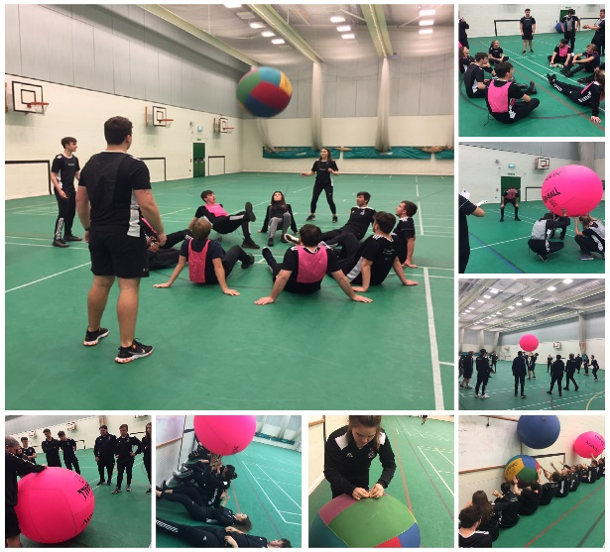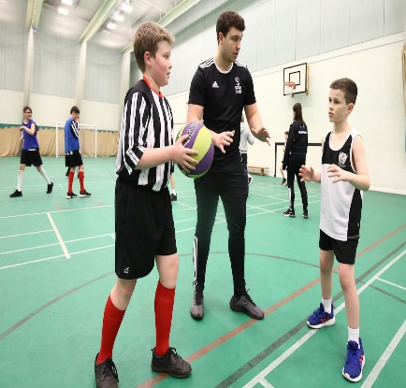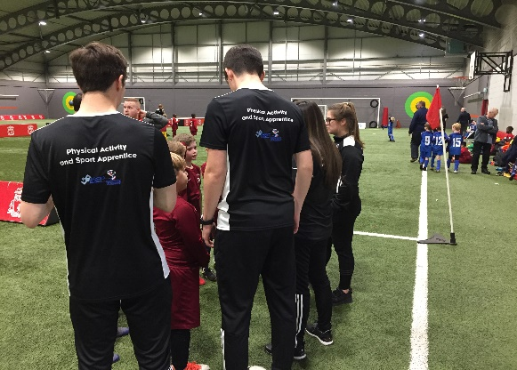Applications should be sent to: **wellesbourne-bm@wellesbourne.liverpool.sch.uk**