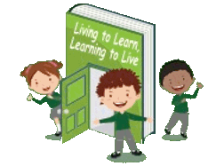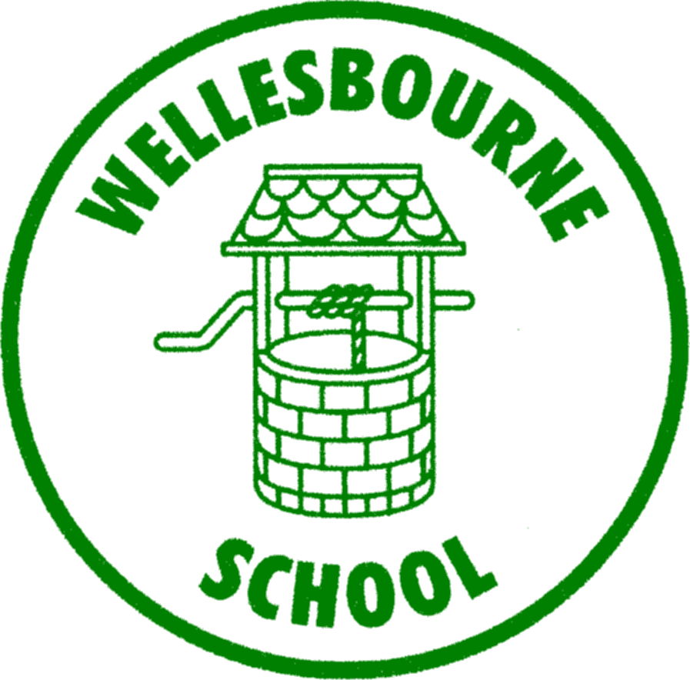

**Wellesbourne Primary and Nursery School**

**Art and Design Curriculum Map**

|  |  |  |  |  |  |  |
| --- | --- | --- | --- | --- | --- | --- |
|  | **Year 1** | **Year 2** | **Year 3** | **Year 4** | **Year 5** | **Year 6** |
| **AUTUMN** | **3D WORK**  **School Collage** | **3D WORK**  **Sewing** | **PAINTING**  **Cave Painting- Prehistoric Art** | **3D WORK**  **Natural Materials mosaic** | **PAINTING / PRINTING**  **Emoji prints- Romero Britto** | **3D-WORK**  **Recycled Sculpture** |
| **SPRING** | **PAINTING**  **Cold and Warm Colours** | **PAINTING**  **Silhouette - Gokonga** | **DRAWING**  **Self-Portraits** | **PAINTING**  **Manga/Anime Poster** | **Drawing**  **Pointillism & Cross Hatching- Van Gogh** | **PAINTING**  **Graffiti Art- Banksy/Paul Curtis** |
| **SUMMER** | **DRAWING**  **Line Drawing - Miro** | **DRAWING**  **Observational Drawing – Paul Klee** | **3D WORK**  **Greek Vase- clay sculpting** | **DRAWING**  **Shadows- Cezanne** | **3D Work**  **Wire Sculpture- Alexander Calder** | **DRAWING**  **Perspective- Lowry** |