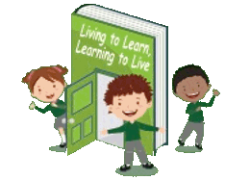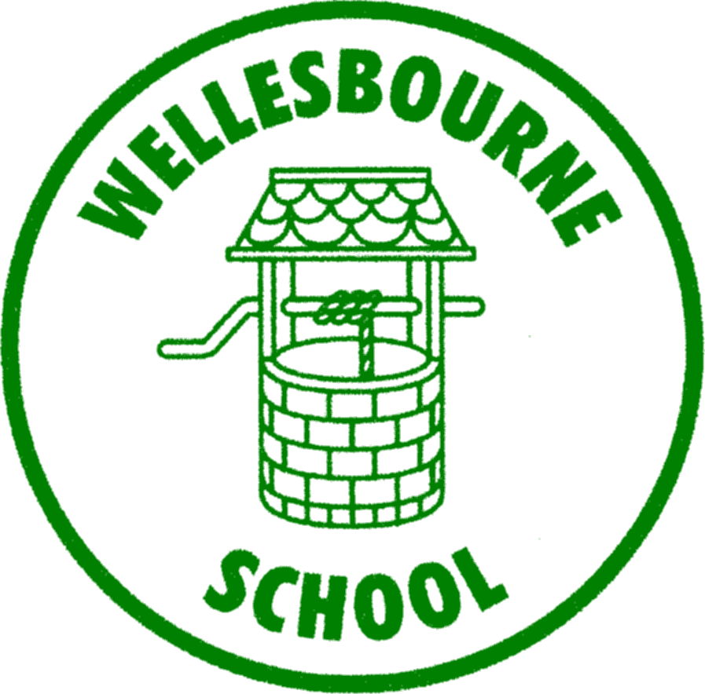

**Wellesbourne Primary and Nursery School**

**Personal, Social, Health and Economical Education**

**Curriculum Map**

|  |  |  |  |  |  |  |
| --- | --- | --- | --- | --- | --- | --- |
|  | **Year 1** | **Year 2** | **Year 3** | **Year 4** | **Year 5** | **Year 6** |
| **AUTUMN** | **FAMILIES AND FRIENDSHIPS**  **SAFE RELATIONSHIPS**  **RESPECTING OURSELVES AND OTHERS** | **FAMILIES AND FRIENDSHIPS**  **SAFE RELATIONSHIPS**  **RESPECTING OURSELVES AND OTHERS** | **FAMILIES AND FRIENDSHIPS**  **SAFE RELATIONSHIPS**  **RESPECTING OURSELVES AND OTHERS** | **FAMILIES AND FRIENDSHIPS**  **SAFE RELATIONSHIPS**  **RESPECTING OURSELVES AND OTHERS** | **FAMILIES AND FRIENDSHIPS**  **SAFE RELATIONSHIPS**  **RESPECTING OURSELVES AND OTHERS** | **FAMILIES AND FRIENDSHIPS**  **SAFE RELATIONSHIPS**  **RESPECTING OURSELVES AND OTHERS** |
| **SPRING** | **BELONGING TO A COMMUNITY**  **MEDIA LITERACY AND DIGITAL RESILIENCE**  **MONEY AND WORK** | **BELONGING TO A COMMUNITY**  **MEDIA LITERACY AND DIGITAL RESILIENCE**  **MONEY AND WORK** | **BELONGING TO A COMMUNITY**  **MEDIA LITERACY AND DIGITAL RESILIENCE**  **MONEY AND WORK** | **BELONGING TO A COMMUNITY**  **MEDIA LITERACY AND DIGITAL RESILIENCE**  **MONEY AND WORK** | **BELONGING TO A COMMUNITY**  **MEDIA LITERACY AND DIGITAL RESILIENCE**  **MONEY AND WORK** | **BELONGING TO A COMMUNITY**  **MEDIA LITERACY AND DIGITAL RESILIENCE**  **MONEY AND WORK** |
| **SUMMER** | **PHYSICAL HEALTH AND MENTAL WELLBEING**  **GROWING AND CHANGING**  **KEEPING SAFE** | **PHYSICAL HEALTH AND MENTAL WELLBEING**  **GROWING AND CHANGING**  **KEEPING SAFE** | **PHYSICAL HEALTH AND MENTAL WELLBEING**  **GROWING AND CHANGING**  **KEEPING SAFE** | **PHYSICAL HEALTH AND MENTAL WELLBEING**  **GROWING AND CHANGING**  **KEEPING SAFE** | **PHYSICAL HEALTH AND MENTAL WELLBEING**  **GROWING AND CHANGING**  **KEEPING SAFE** | **PHYSICAL HEALTH AND MENTAL WELLBEING**  **GROWING AND CHANGING**  **KEEPING SAFE** |