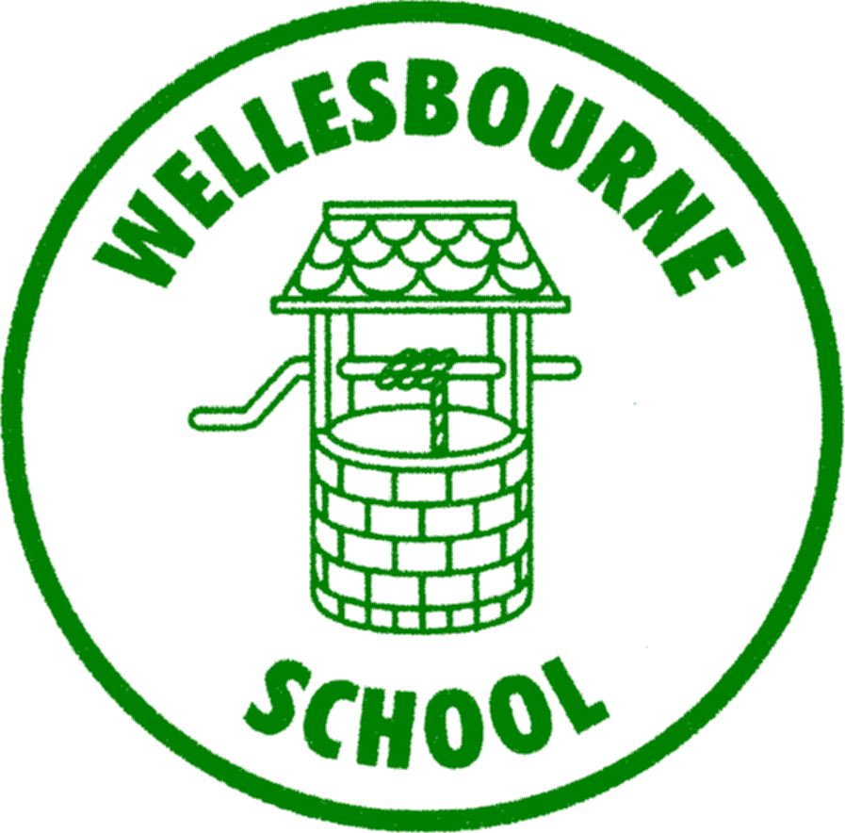 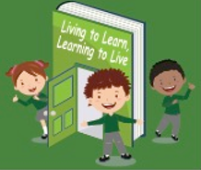 

**WELLESBOURNE PRIMARY**

**AND NURSERY SCHOOL**

**REACH for the stars**

**Safeguarding Statement**

All of the adults around s think that our health, safety and welfare are very important.

In our school, we respect all children and adults, and help to protect their rights.

We do our best to help all children make good educational progress.

Children are taught how to recognise risks in different situations, and how to protect themselves and stay safe.

**How are children protected at Wellesbourne?**

We provide a safe environment for children to learn in:

Where everyone has the right to feel **SAFE**; the right to **LEARN** without undue distraction or disruption; the right to **RESPECT**.

We help to ensure that children remain safe, at home as well as at school.

We think it is important for our children to know where to get help if they are worried or unhappy about something.

**Need to talk?**

You can talk to any adult in school if you need to, just ask or use the worry boxes – pop in a note with your name and just say you want to talk.

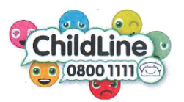

**Respect**   **Effort Attend Cooperate Honest**