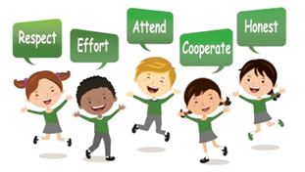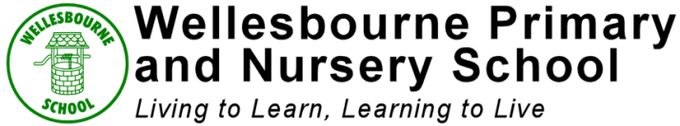

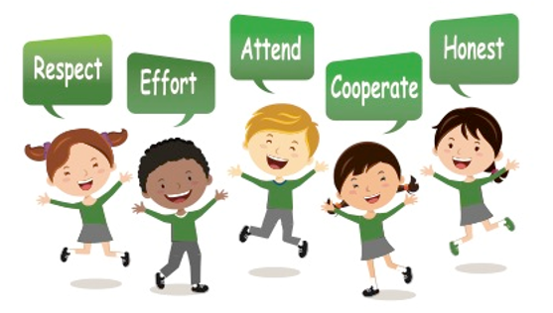

**Progression of Skills in Art and design**

|  |  |  |  |
| --- | --- | --- | --- |
|  | **Drawing** | **Painting/Printing** | **3D Work** |
| Nursery | Pupils will create closed shapes with continuous lines, and begin to use these shapes to represent objects.  Pupils will draw with increasing complexity and detail.  Pupils will use drawing to represent ideas like movement or loud noises.  Pupils will show different emotions in their drawings and paintings.  Pupils will explore colour and colour-mixing. | | |
| Reception | Pupils will explore, use and refine a variety of artistic effects to express their ideas and feelings.  Pupils will safely use and explore a variety of materials, tools and techniques, experimenting with colour, design, texture, form and function.  Pupils will share their creations, explaining the process they have used. | | |
| Year 1 | Pupils will begin to explore the use of line, shape and colour.  Pupils will begin to explore a variety of tools including pencils, pastels and chalks. | Pupils will begin to explore and choose to use thick and thin brushes as appropriate.  Pupils will name and use warm and cold colours. | Pupils will become aware of form, feel and texture.  Pupils will group materials by their properties e.g. warm, cold, shiny, smooth etc.  Pupils will cut and tear paper and card for collages. |
| Year 2 | Pupils will use lines and tone to represent things seen, remembered or observed.  Pupils will experiment with and enjoy colour.  Pupils will create pattern using different tools and colours. | Pupils will mix paint to create all the secondary colours.  Pupils will begin to make tones and shades.  Create a print using pressing, rolling or stamping. | Pupils will engage with cutting and sewing materials.  Pupils will use simple weaving with fabric and card. |
| Year 3 | Pupils will draw familiar things from different viewpoints.  Pupils will represent things observed, remembered or imagined with improved accuracy.  Begin to use different media (pencil, charcoal) to achieve variations in line, texture, tone, colour, shape and pattern. | Pupils will predict with accuracy the colours that they mix.  Pupils will choose to use a range of brushes to create different effects. | Pupils will begin to sculpt with clay and other mouldable materials.  Pupils will recreate 2D images in a 3D piece.  Pupils will develop awareness of contrasts in textures and colour. |
| Year 4 | Pupils explore the relationship between line and tone, pattern and shape, line and texture.  Pupils begin to identify and draw the effect of light (shadows) on a surface, objects and people.  Pupils will alter and refine drawings. | Pupils will be able to create the colours they need to paint.  Pupils will explore the effect on paint by adding water, glue etc.  Successfully use shading, tone and brushstroke to create mood and feeling. | Pupils will experiment with and combine different materials and processes to design and make 3D form.  Pupils will use techniques to create different textural effects e.g. collage. |
| Year 5 | Pupils will use a range of materials to produce line, tone and shade  Pupils will explore the potential properties of the visual elements, line, tone, pattern, texture, colour and shape (e.g. cross hatch).  Pupils use a variety of techniques to show the effect of light on objects and people. | Pupils will independently create and name the colours they need inc the difference between primary, secondary, tertiary and metallic colours.  Pupils will create printing blocks by simplifying an initial sketch book idea.  Pupils will use relief impressed methods.  Pupils will create prints with three overlays. | Pupils will show understanding of shape, space and form.  Pupils will manipulate materials to create 3D structures. |
| Year 6 | Pupils will manipulate and experiment with line, tone, pattern, texture, form, space, colour and shape.  Pupils will look at the effect of light on a shape from different directions.  Pupils will explore the concept of perspective. | Pupils will paint onto different materials and work with a range of media (e.g. pens, coloured pens, paints etc.).  Pupils will use mixed media experimentations in work: working on cardboard, involving biros and coloured pencils. | Pupils will independently select materials and techniques to create a 3D sculpture. |