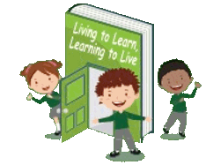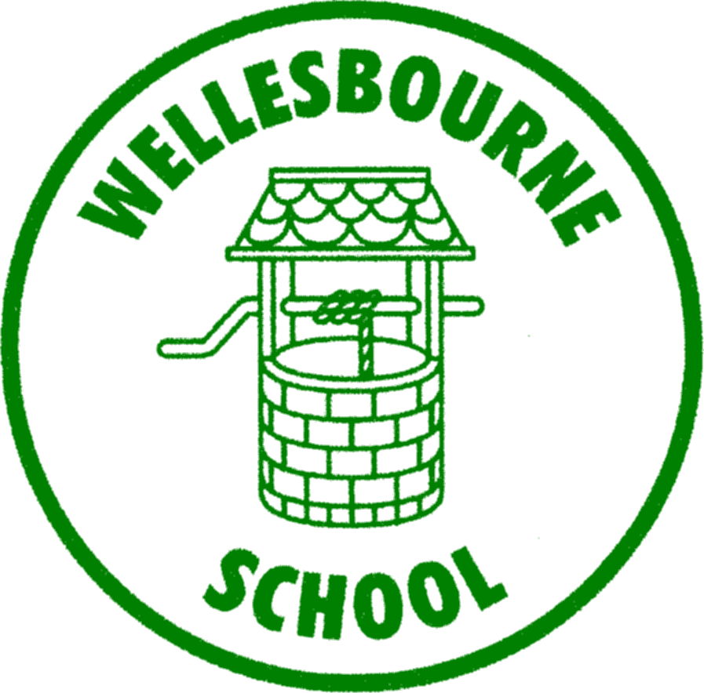

**Wellesbourne Primary and Nursery School**

**Science Curriculum Map**

|  |  |  |  |  |  |  |
| --- | --- | --- | --- | --- | --- | --- |
|  | **Year 1** | **Year 2** | **Year 3** | **Year 4** | **Year 5** | **Year 6** |
| **AUTUMN** | **EVERYDAY MATERIALS**  **SEASONAL CHANGES** | **GROWTH AND SURVIVAL**  **EXPLORING EVERYDAY MATERIALS** | **ROCKS, FOSSILS AND SOILS**  **HEALTH AND MOVEMENT** | **CHANGING SOUND**  **CIRCUITS AND CONDUCTORS** | **PROPERTIES AND CHANGES OF MATERIALS**    **FORCES IN ACTION** | **HEALTHY BODIES**  **CLASSIFYING ORGANISMS** |
| **SPRING** | **IDENTIFY ANIMALS**  **MY BODY** | **GROWING PLANTS**  **SUPER SCIENTISTS** | **HOW PLANTS GROW**  **FORCES AND MAGNETS** | **STATES OF MATTER**  **EATING AND DIGESTION** | **EARTH AND SPACE** | **EVOLUTION AND INHERITANCE** |
| **SUMMER** | **IDENTIFYING PLANTS**  **SEASONAL CHANGES** | **LIVING IN HABITATS** | **LIGHT AND SHADOW** | **LIVING IN ENVIRONMENTS** | **LIFE CYCLES**  **CHANGES AND REPRODUCTION** | **CHANGING CIRCUITS**  **SEEING LIGHT** |